CPSY 300 · CLOUD COMPUTING · PROJECT 2
Stage 1 Backend Summary
Local Data Processing & Nutritional Insights API
Scope: Person 1 · Stage 1 | Verified: 2026-11-04
This page summarises the Stage 1 implementation and its evidence. Person numbering follows the team's division of work.

01 / Delivery at a Glance
4 | 7,806 | 44 | 5
GET API endpoints | recipes in the dataset | automated tests passing | diet types

Stage 1 of Project2/division.md is delivered as a self-contained folder. It reuses the cleaning, aggregation and test foundation of the existing backend, and adds local CSV loading, text search, a correlation matrix and a k-means implementation written from scratch with NumPy, behind an API contract the front end can build against.
Status: Stage 1 is complete and evidenced. On Python 3.11 all 44 tests pass and flake8 reports nothing; func start from Azure Functions Core Tools 4.16.0 registers all four routes; ten real HTTP cases pass, including the 400 / 404 paths and the local CORS response header; four browser screenshots and three terminal screenshots are archived in docs/screenshots/. Stage 1 involves no cloud deployment — the group's Azure release, report and video belong to Stages 2 and 3.

02 / Stage 1 Requirements Checklist
Requirement from the division of work | Where it lives and how it is evidenced | Status
Python project, dependencies, host configuration | requirements.txt, host.json, local settings template | Done
Load and clean the local CSV | function_app.py, nutrition.py, data/All_Diets.csv | Verified
Health / Insights / Recipes / Clusters | 4 GET routes; every call over the full dataset returns 200 | Verified
Endpoint tests, flake8, API documentation | tests/, README.md, docs/verification.txt | Done
Run locally, screenshots, merge to main | func start 4.16.0 registers 4 routes; verify_http.py runs 10 real HTTP cases; 7 images in docs/screenshots/ | Verified

Checked against the instructor's phase2-requirements.docx: it asks for cloud deployment, at least three visualizations, interactive controls, execution timing and front-end/back-end integration. It does not specifically require k-means or four APIs — clustering, search and the correlation matrix come from Stage 1 of the team's own division.md.
03 / Structure and Data Processing
Local All_Diets.csv → Pandas cleaning → Statistics / NumPy clustering → Azure Functions JSON
Cleaning rules
- Strip whitespace from column names and text; normalise diet and cuisine casing.
- Missing categories become unknown; a missing recipe name becomes Unnamed recipe.
- Invalid, missing, negative and infinite nutrient values are filled with the column's valid mean.
- Empty data, a missing required column, or a column with no valid value at all is rejected.
Project layout
stage1/
├── function_app.py
├── nutrition.py / clustering.py
├── host.json / requirements*.txt
├── local.settings.json.example
├── verify_http.py
├── data/All_Diets.csv
├── tests/ (3 test files)
├── docs/ (measured results, verification record, screenshots)
├── README.md
└── summary.html

Stage 1 does not use Blob Storage. The cache is keyed on file path, modification time and size; Stage 3 switches the loader to Azure Blob.
04 / API Contract and Front-End Hand-Off
Base URL: http://localhost:7071/api. Every endpoint returns JSON, and each data endpoint reports its execution time, source and cache state.
GET route | Input | Main output and purpose
/health | none | Service status; touches no data, so it works as a liveness check.
/insights | none | average_macros → bar chart; summary.diet_counts → pie chart; correlation → heatmap.
/recipes | diet_type, search, page, limit | Recipe rows plus paging fields. search matches recipe name, diet type and cuisine, and combines with the filter.
/clusters | k, default 3, range 1–10 | points, centroids, cluster_counts → scatter chart coloured by cluster.

Paging defaults to 50 rows and is capped at 500; pages are 1-based and a page past the end returns the last page. Invalid parameters return 400 and an unknown diet type returns 404. A search with no match returns an empty list. Internal errors return a generic error JSON.
The existing frontend/ still targets the earlier three-endpoint version; the new controls and charts are Person 2's work. The CORS template allows localhost:5500 and 127.0.0.1:5500.
05 / Measured Results on the Full Dataset
The figures below come from the cleaned local CSV. All 7,806 recipes take part in the statistics and the clustering.
Recipes per diet type
Diet type | Recipes | Relative size
mediterranean | 1,753 | 100.0%
dash | 1,745 | 99.5%
vegan | 1,522 | 86.8%
keto | 1,512 | 86.3%
paleo | 1,274 | 72.7%

Average macros (grams)
Diet | Protein | Carbs | Fat
dash | 69.28 | 160.54 | 101.15
keto | 101.27 | 57.97 | 153.12
mediterranean | 101.11 | 152.91 | 101.42
paleo | 88.67 | 129.55 | 135.67
vegan | 56.16 | 254.0 | 103.3

NumPy k-means
Protein, carbohydrate and fat are the three features. They are z-score standardized first so that no unit scale dominates the distance. The random seed is fixed at 42 and the centroids start from distinct sample vectors; the loop then alternates nearest-centroid assignment and cluster-mean updates for at most 100 iterations. A constant feature uses a scale of 1, and an empty cluster keeps its previous centroid, so no NaN can appear.
Measured grouping at k = 3: cluster 0 holds 1,205 recipes, cluster 1 holds 5,681 and cluster 2 holds 920. The returned points and centroids are converted back to grams, while inertia stays as the sum of squared distances in the standardized space.
Cluster numbers carry no dietary meaning. This is exploratory grouping, and a single initialisation is not guaranteed to be globally optimal. Undefined values in the correlation matrix are encoded as null.
06 / Tests and Evidence
$ .venv311/bin/python --version
Python 3.11.18

$ python -m pytest -q
............................................ [100%]
44 passed in 0.49s

$ python -m flake8 . --exclude=.venv,.venv311
Exit code 0 — no findings

$ func start --port 7071
Core Tools Version: 4.16.0
Functions: clusters / health / insights / recipes [GET] http://localhost:7071/api/...

$ python verify_http.py
PASS 200 GET /api/health
PASS 200 GET /api/insights
PASS 200 GET /api/recipes?diet_type=keto&search=chicken&page=1&limit=5
PASS 200 GET /api/recipes?diet_type=keto&search=chicken&page=2&limit=5
PASS 200 GET /api/recipes?search=stage1-no-match-000000
PASS 200 GET /api/clusters?k=3
PASS 400 GET /api/clusters?k=0
PASS 400 GET /api/clusters?k=11
PASS 400 GET /api/recipes?page=0
PASS 404 GET /api/recipes?diet_type=nonexistent
PASS payload assertions and local CORS; evidence: docs/http-results.json

The tests cover cleaning and imputation, the aggregations, endpoint output, filtering and paging, literal search, constant columns in the correlation matrix, k-means reproducibility and grouping, invalid k, local CSV cache refresh, and the error responses.
The actual Azure Functions handlers were also called against the full CSV: all four return status 200, and both the insights total and the clusters point count are 7,806. On top of that, verify_http.py sends ten real HTTP requests through the running Functions host and asserts each one: the success paths, that pages 1 and 2 differ, the empty search result, 400 for an invalid k and an invalid page, 404 for an unknown diet type, and the Access-Control-Allow-Origin: http://localhost:5500 response header.
Verification record · In-process API results (JSON) · Real HTTP results (JSON) · Run instructions and API reference
Verification environment: macOS (arm64), Python 3.11.18 (the version the team's project already uses), the isolated .venv311 virtual environment, Azure Functions Core Tools 4.16.0 and Functions Runtime 4.1054.250.26428. Local host compatibility was confirmed in that environment.

Stage 1 Local-Run Screenshots (2026-11-04)
The seven images below are the actual run evidence on Python 3.11 with Core Tools 4.16.0. Every one was taken with the macOS screencapture tool from a real window on screen: the browser images are Google Chrome windows with the address bar visible, running in a separate empty profile so no personal browsing data appears, and the terminal images are real command output in Terminal.app windows. The images are embedded, so this HTML can be sent on its own.
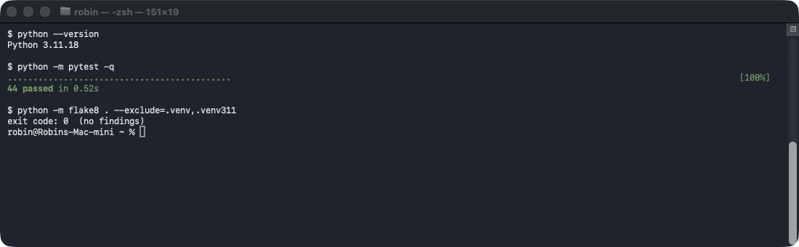
Figure S1 — All 44 pytest tests pass and flake8 exits 0 on Python 3.11. ( docs/screenshots/cli-pytest-flake8.png )
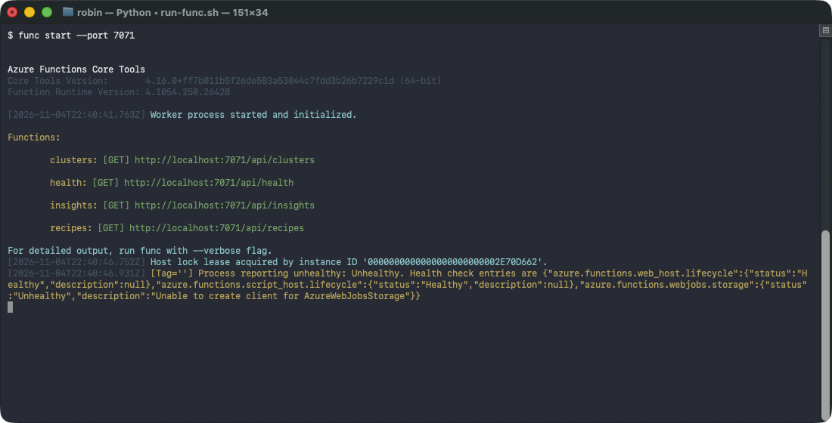
Figure S2 — func start brings up the local Functions host; the clusters, health, insights and recipes GET routes are all registered. ( docs/screenshots/cli-func-start.png )
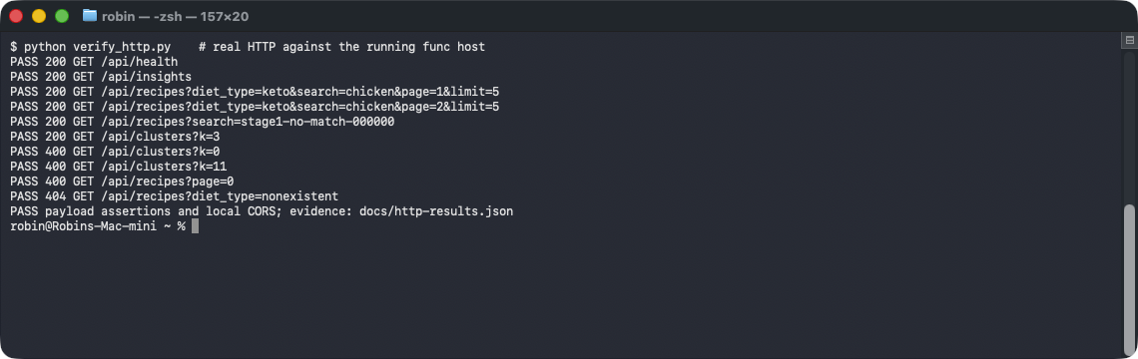
Figure S3 — Ten real HTTP requests through the running host, including the 400 / 404 paths and the local CORS header, all pass. ( docs/screenshots/cli-http-verification.png )
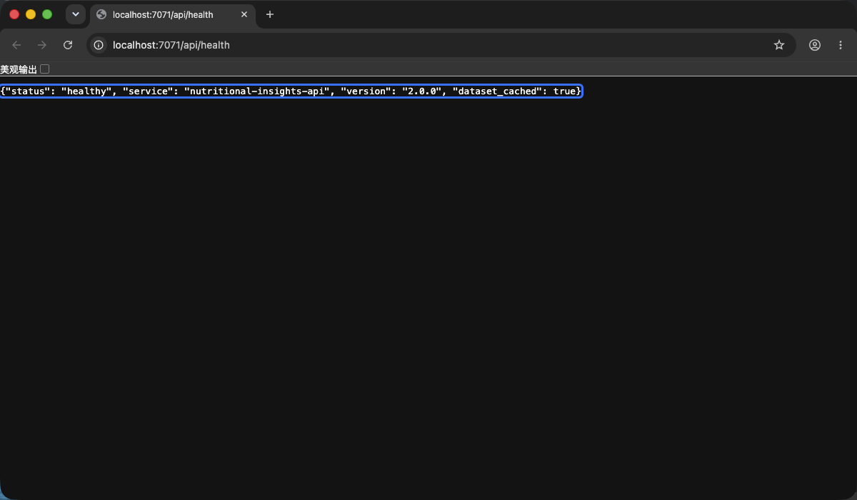
Figure S4 — Browser response from http://localhost:7071/api/health. ( docs/screenshots/api-health-browser.png )
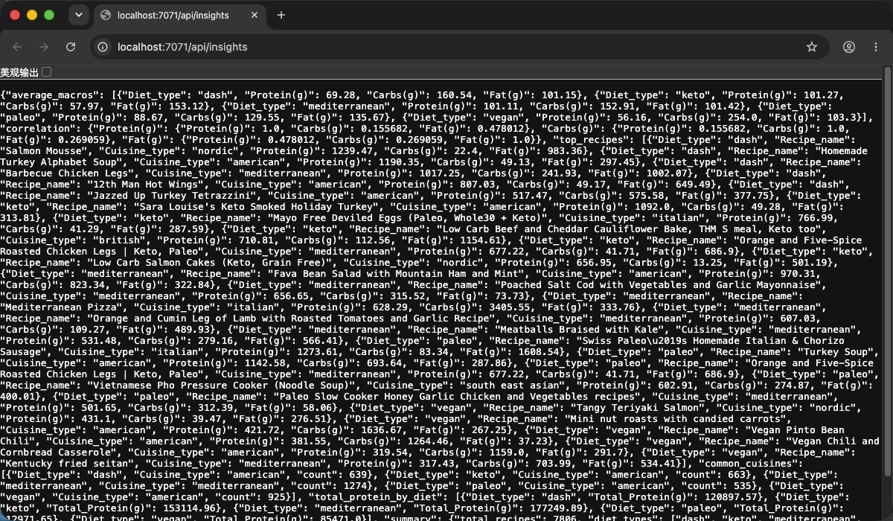
Figure S5 — /api/insights in the browser: average macros per diet, the correlation matrix and the execution time. ( docs/screenshots/api-insights-browser.png )
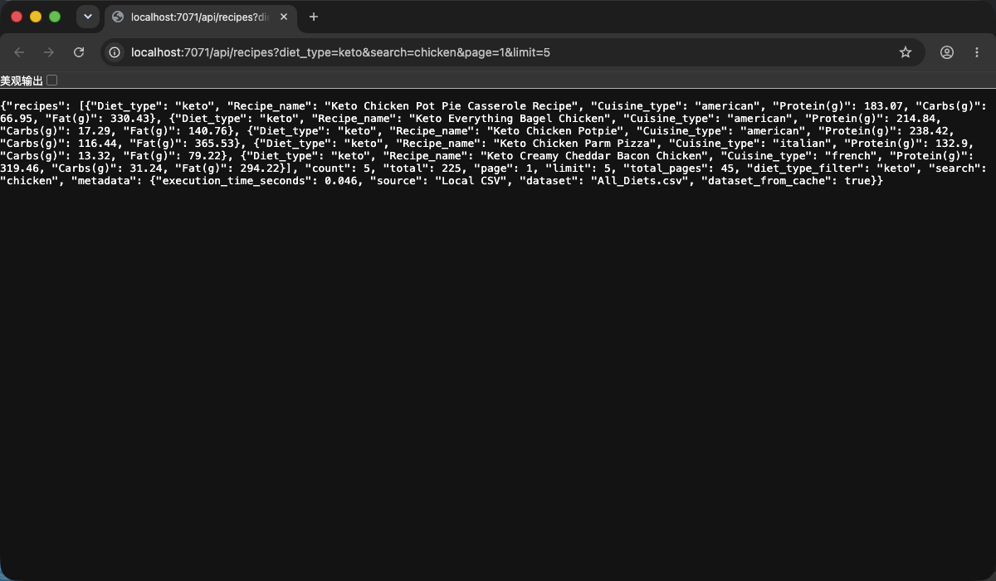
Figure S6 — /api/recipes?diet_type=keto&search=chicken&page=1&limit=5 in the browser: filtering, search and the paging fields. ( docs/screenshots/api-recipes-browser.png )
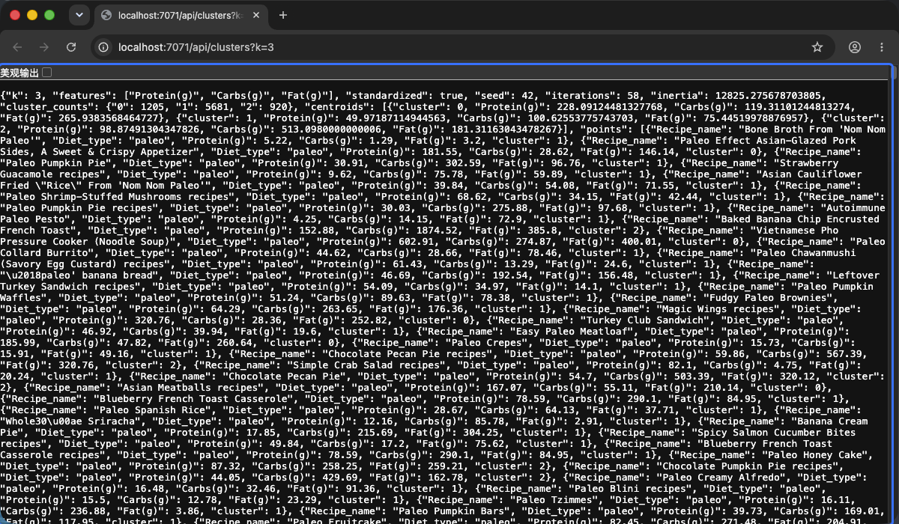
Figure S7 — /api/clusters?k=3 in the browser: cluster sizes, centroids and the scatter points from the hand-written k-means. ( docs/screenshots/api-clusters-browser.png )
Existing Screenshots and Cloud Evidence
The images below are screenshots the project already held, each one checked against its source. They evidence the deployment and responses of the earlier three-endpoint backend; the new search, correlation and clusters features are evidenced by the Stage 1 record above. The images are embedded, so this HTML can be sent on its own.
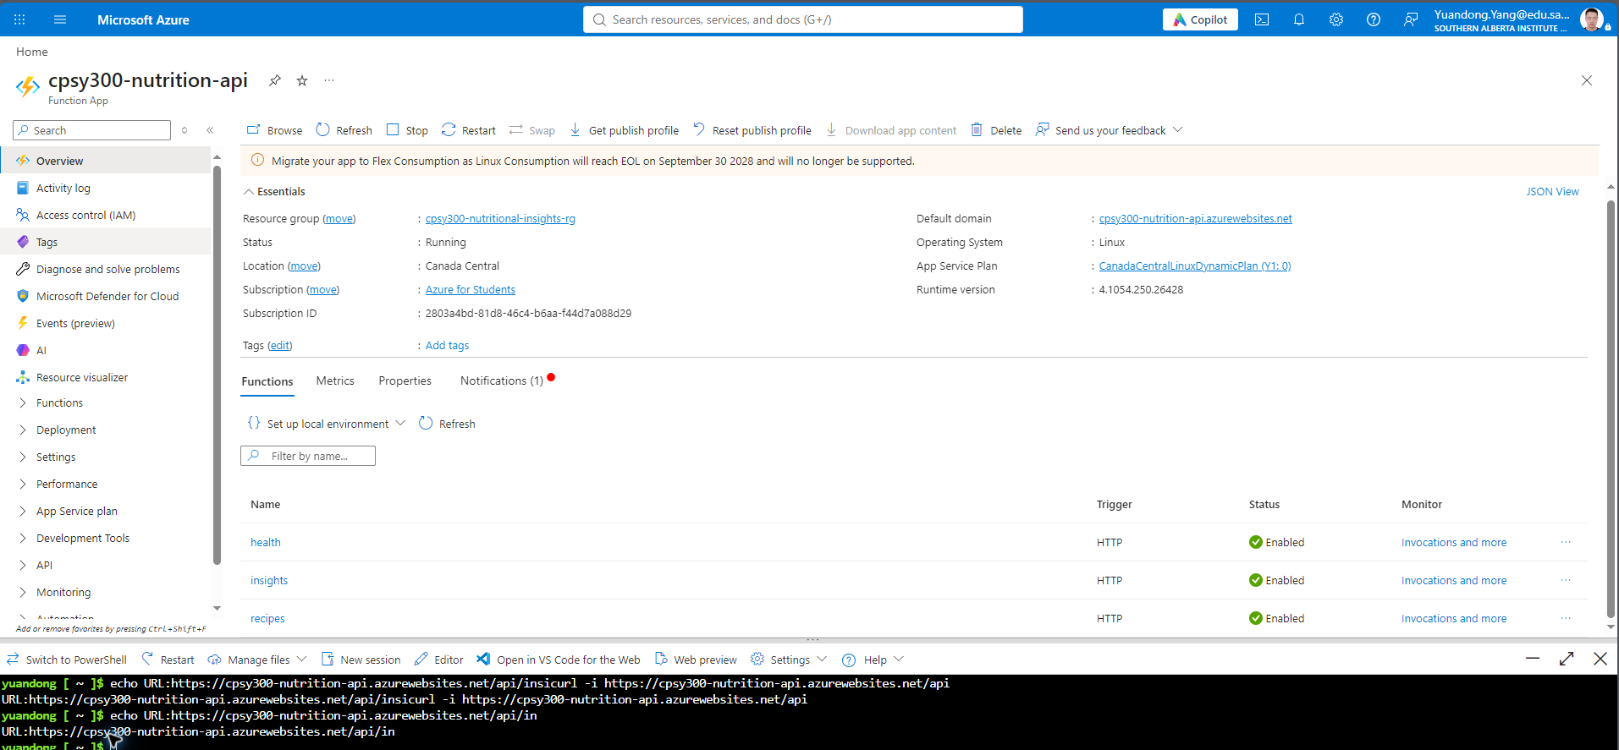
Figure 1 · Existing Azure Function App: Running, with the health, insights and recipes HTTP functions enabled. Source: Project2/docs/screenshots/portal-function-app.png
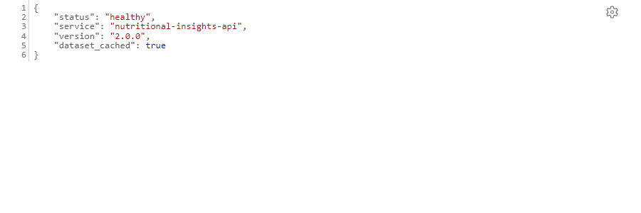
Figure 2 · Existing health response: status=healthy, service version 2.0.0. Source: Project2/docs/screenshots/api-health-curl.png
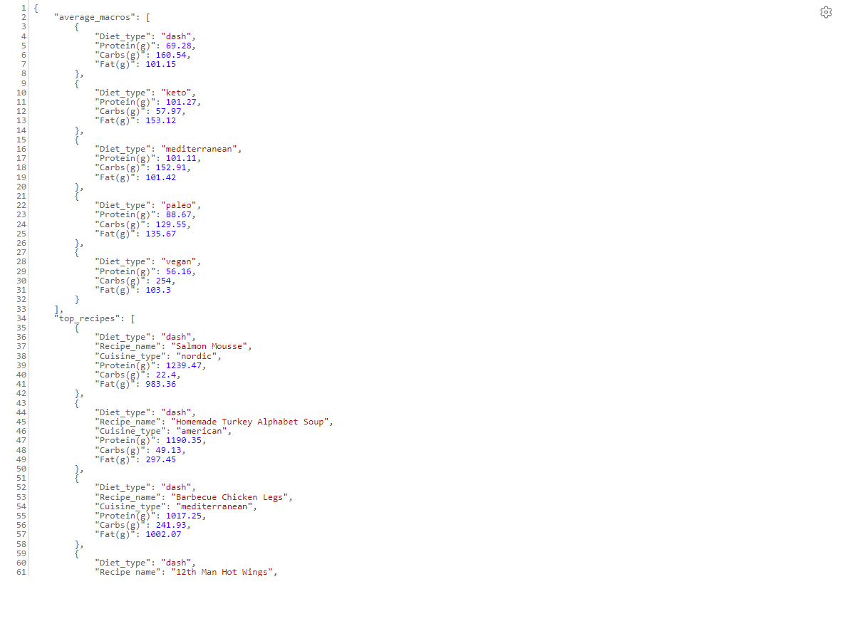
Figure 3 · Existing insights response: average macros for the five diet types and the highest-protein recipes. Source: Project2/docs/screenshots/api-insights-browser.png
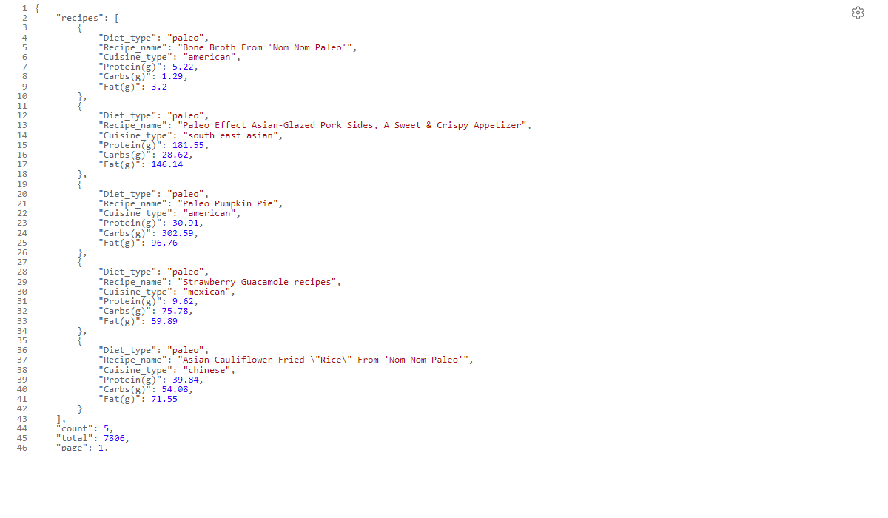
Figure 4 · Existing recipes response: 5 recipes, a total of 7,806 and the first page of results. Source: Project2/docs/screenshots/api-recipes-response.png
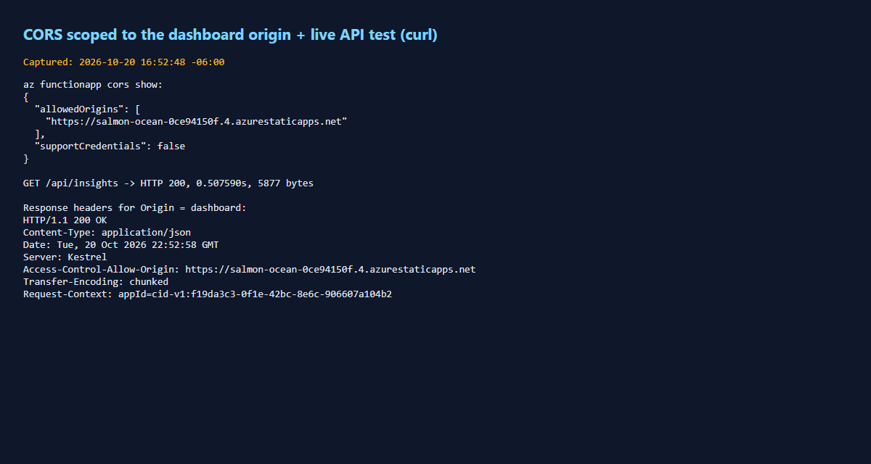
Figure 5 · Existing CORS and timing record: insights HTTP 200 on 2026-10-20, the measured duration and the allowed front-end origin. Source: Project2/docs/screenshots/cli-cors-and-timing.png
07 / Sample JSON Responses
Click to expand. These are measured values; insights omits the extra statistics lists and clusters shows only the first two points. The complete payloads are in the JSON files linked above.
GET /api/health · live JSON response
{
"status": "healthy",
"service": "nutritional-insights-api",
"version": "2.0.0",
"dataset_cached": false
}

GET /api/insights · live JSON response
{
"average_macros": [
{
"Diet_type": "dash",
"Protein(g)": 69.28,
"Carbs(g)": 160.54,
"Fat(g)": 101.15
},
{
"Diet_type": "keto",
"Protein(g)": 101.27,
"Carbs(g)": 57.97,
"Fat(g)": 153.12
},
{
"Diet_type": "mediterranean",
"Protein(g)": 101.11,
"Carbs(g)": 152.91,
"Fat(g)": 101.42
},
{
"Diet_type": "paleo",
"Protein(g)": 88.67,
"Carbs(g)": 129.55,
"Fat(g)": 135.67
},
{
"Diet_type": "vegan",
"Protein(g)": 56.16,
"Carbs(g)": 254.0,
"Fat(g)": 103.3
}
],
"correlation": {
"Protein(g)": {
"Protein(g)": 1.0,
"Carbs(g)": 0.155682,
"Fat(g)": 0.478012
},
"Carbs(g)": {
"Protein(g)": 0.155682,
"Carbs(g)": 1.0,
"Fat(g)": 0.269059
},
"Fat(g)": {
"Protein(g)": 0.478012,
"Carbs(g)": 0.269059,
"Fat(g)": 1.0
}
},
"summary": {
"total_recipes": 7806,
"diet_types": [
"dash",
"keto",
"mediterranean",
"paleo",
"vegan"
],
"diet_counts": {
"mediterranean": 1753,
"dash": 1745,
"vegan": 1522,
"keto": 1512,
"paleo": 1274
},
"highest_mean_protein_diet": "keto",
"highest_mean_protein_g": 101.27,
"highest_total_protein_diet": "mediterranean",
"highest_total_protein_g": 177249.89
},
"metadata": {
"execution_time_seconds": 0.027,
"source": "Local CSV",
"dataset": "All_Diets.csv",
"dataset_from_cache": false
}
}

GET /api/recipes · live JSON response
{
"recipes": [
{
"Diet_type": "keto",
"Recipe_name": "Keto Chicken Pot Pie Casserole Recipe",
"Cuisine_type": "american",
"Protein(g)": 183.07,
"Carbs(g)": 66.95,
"Fat(g)": 330.43
},
{
"Diet_type": "keto",
"Recipe_name": "Keto Everything Bagel Chicken",
"Cuisine_type": "american",
"Protein(g)": 214.84,
"Carbs(g)": 17.29,
"Fat(g)": 140.76
}
],
"count": 2,
"total": 225,
"page": 1,
"limit": 2,
"total_pages": 113,
"diet_type_filter": "keto",
"search": "chicken",
"metadata": {
"execution_time_seconds": 0.002,
"source": "Local CSV",
"dataset": "All_Diets.csv",
"dataset_from_cache": true
}
}

GET /api/clusters · live JSON response
{
"k": 3,
"features": [
"Protein(g)",
"Carbs(g)",
"Fat(g)"
],
"standardized": true,
"seed": 42,
"iterations": 58,
"inertia": 12825.275678703805,
"cluster_counts": {
"0": 1205,
"1": 5681,
"2": 920
},
"centroids": [
{
"cluster": 0,
"Protein(g)": 228.09124481327768,
"Carbs(g)": 119.31101244813274,
"Fat(g)": 265.9383568464727
},
{
"cluster": 1,
"Protein(g)": 49.97187114944563,
"Carbs(g)": 100.62553775743703,
"Fat(g)": 75.44519978876957
},
{
"cluster": 2,
"Protein(g)": 98.87491304347826,
"Carbs(g)": 513.0980000000006,
"Fat(g)": 181.31163043478267
}
],
"points": [
{
"Recipe_name": "Bone Broth From 'Nom Nom Paleo'",
"Diet_type": "paleo",
"Protein(g)": 5.22,
"Carbs(g)": 1.29,
"Fat(g)": 3.2,
"cluster": 1
},
{
"Recipe_name": "Paleo Effect Asian-Glazed Pork Sides, A Sweet & Crispy Appetizer",
"Diet_type": "paleo",
"Protein(g)": 181.55,
"Carbs(g)": 28.62,
"Fat(g)": 146.14,
"cluster": 0
}
],
"metadata": {
"execution_time_seconds": 0.026,
"source": "Local CSV",
"dataset": "All_Diets.csv",
"dataset_from_cache": true
}
}

08 / Run, Demo and Submission Checklist
cd Project2/stage1
python3.11 -m venv .venv311
source .venv311/bin/activate
python -m pip install -r requirements-dev.txt
cp local.settings.json.example local.settings.json
python -m pytest -q
python -m flake8 . --exclude=.venv,.venv311
func start --port 7071
# in a second terminal:
python verify_http.py

The last two commands need Azure Functions Core Tools v4 (npm i -g azure-functions-core-tools@4). No cloud account or key is required for any endpoint.
- pytest all green and flake8 clean — done, see Figure S1.
- Start the Functions host and open /api/health and /api/insights — done, see Figures S2, S4 and S5.
- /api/recipes?diet_type=keto&search=chicken&page=1&limit=5 for filtering, search and paging — done, see Figure S6; verify_http.py asserts that page 2 differs from page 1.
- /api/clusters?k=3 for cluster sizes, centroids and points — done, see Figure S7.
- The code is committed and merged to main, and the API contract is handed to Person 2; Person 3 takes on Blob Storage, cloud deployment and the final report.
Group submission: working Azure back-end and front-end links, the GitHub repository, a PDF/Word document with screenshots covering each rubric row, and a roughly 10-minute video featuring every member. The project already holds cloud deployment screenshots and the group report; this round did not re-check whether the remote services are still online, and Stage 1 did its verification locally without any cloud release or configuration change. This HTML is the Stage 1 summary and can be printed to PDF and folded into the group report.

Sources: Project2/division.md, spec/submission-requirements.md, the existing backend and tests, and the Stage 1 measurements taken here. The original deployment folder is unchanged, and the existing deploy.sh still targets backend/.

Nutritional Insights Dashboard – Phase 2 Screenshots
Nov 6, 2026, Ethan Temujin Bayarsaikhan
GitHub Repository
https://github.com/etemujin/project2cloud: frontend code in stage2 folder, backend code in stage 1 folder.
Architecture
The dashboard is a static website (HTML, CSS and JavaScript, with Chart.js for the charts) that calls python azure functions. This is for API’s over HTTP with the four endpoints being: health, insights, recipes and clusters. Then it loads and cleans the data sets from the csv, computes averages, corrections and k clusters. Then after that returns a JSON that contains exec time. In Azure the api runs on a function app and the dataset is stored in blob storage and the dashboard is hosted on static web apps all in one RG.
When the page is opened, it calls all the previous end points for the respective parts in the code to then fill in the charts via insights, health for status badge, the clusters for scatter plot, and recipes for the bottom search.
Services
Azure functions host the endpoints as four HTTP triggered py functions, they were developed plus tested locally with azure. Azure blob storage holds the csv, the functions, and the static web app hosts the dashboard files as well as the RG.
The API as well provides services to the dashboard, health reports if the backend is running. Insights returns the macros per diet, recipes counts as well per diet. Recipes returns all recipes filtered by diet, and clusters groups them all into k clusters.
Deployment (Azure Cloud)
Frontend Dashboard
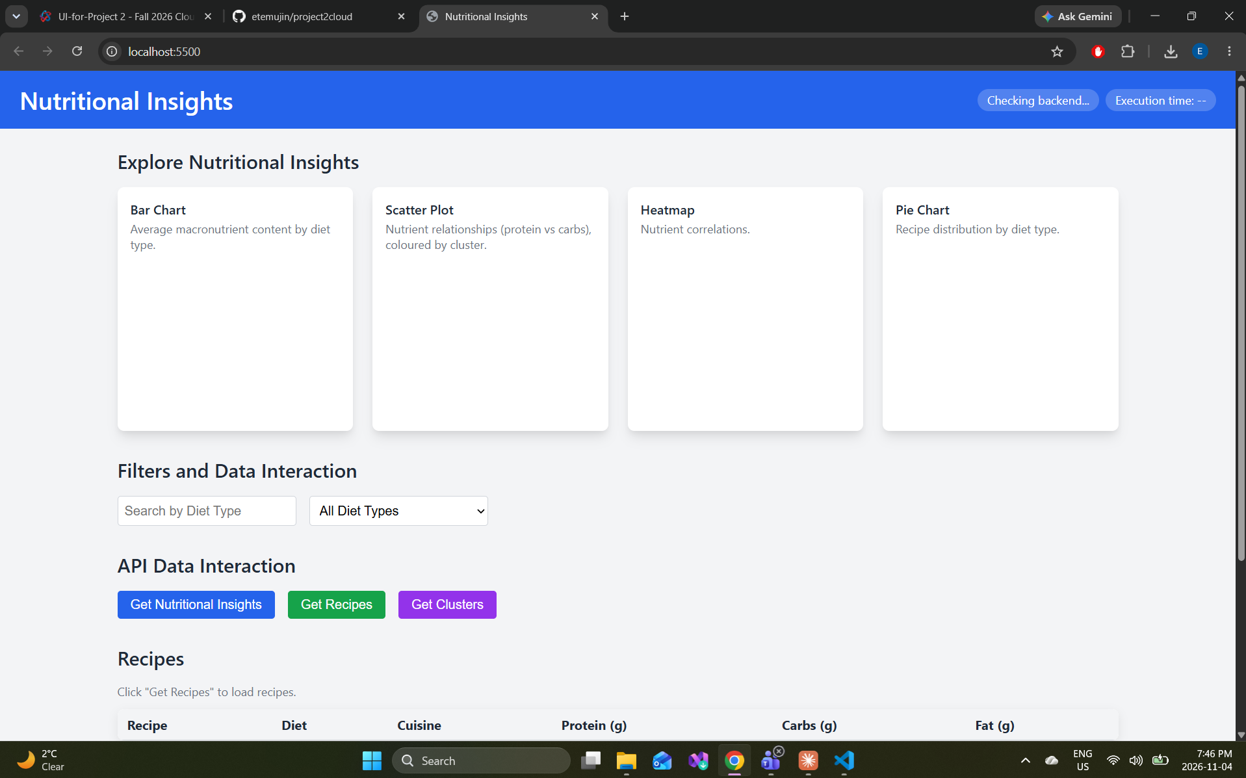
Figure 1 – Dashboard layout (sc 3). The layout follows the course skeleton: a header with backend-health and execution-time badges, four chart cards, search and diet filters, three refresh buttons and the recipe table.
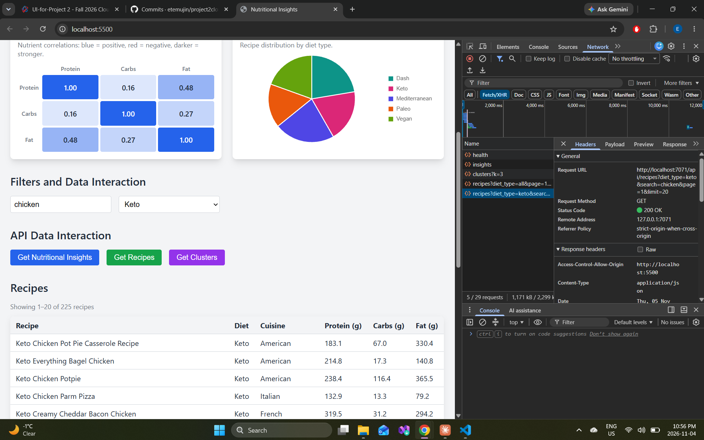
Figure 2 – Search, filter and recipe table (sc 9). Searching "chicken" with the Keto filter returns 225 recipes, shown 20 per page. DevTools shows the request URL with its parameters and the CORS header allowing http://localhost:5500.
Data Visualization
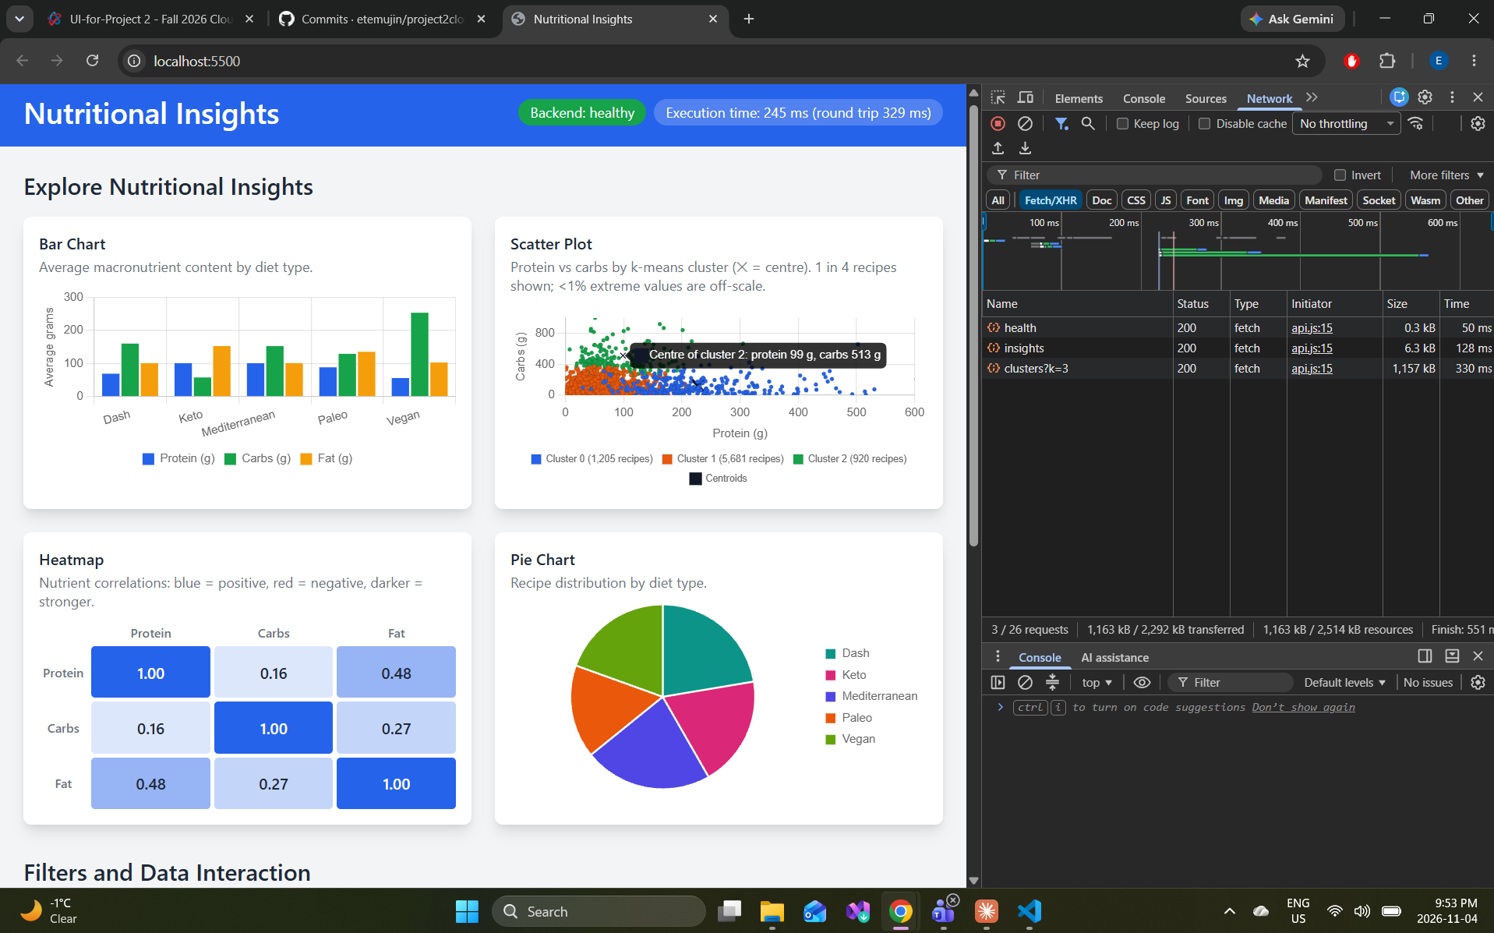
Figure 3 – All four visualizations (sc 8). The bar chart, k-means scatter plot (3 clusters, centres marked with ✕), correlation heatmap and pie chart are all drawn from the API. The Network tab shows the health, insights and clusters requests returning 200.
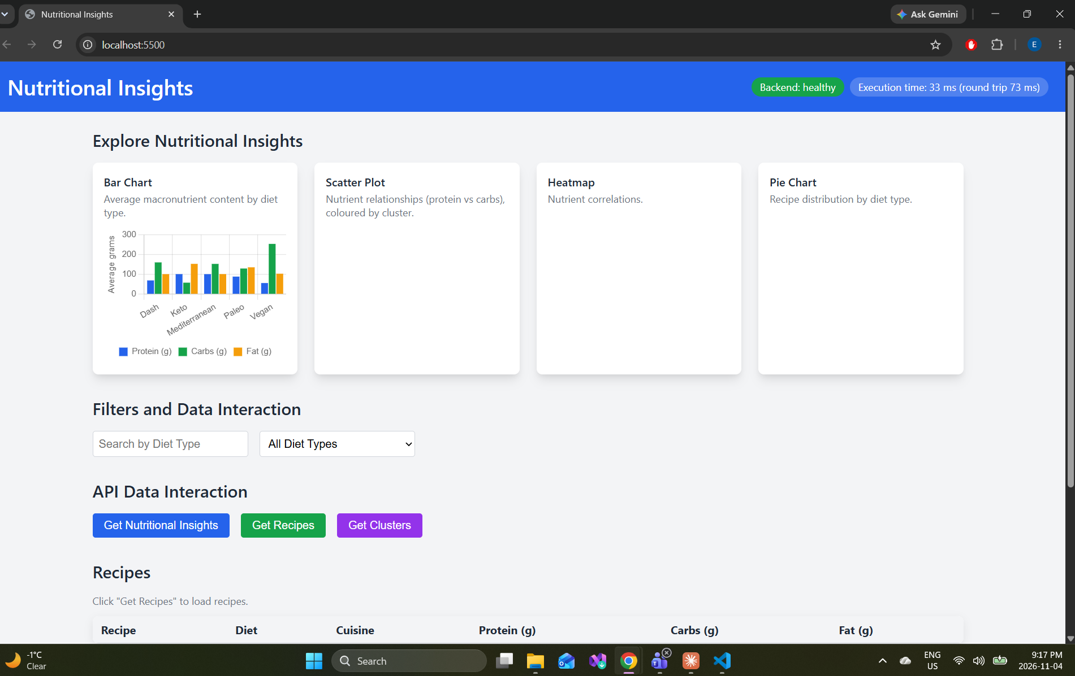
Figure 4 – Bar chart (sc 5). Average protein, carbs and fat per diet type, from /insights . Vegan recipes have the most carbs and keto the most fat.
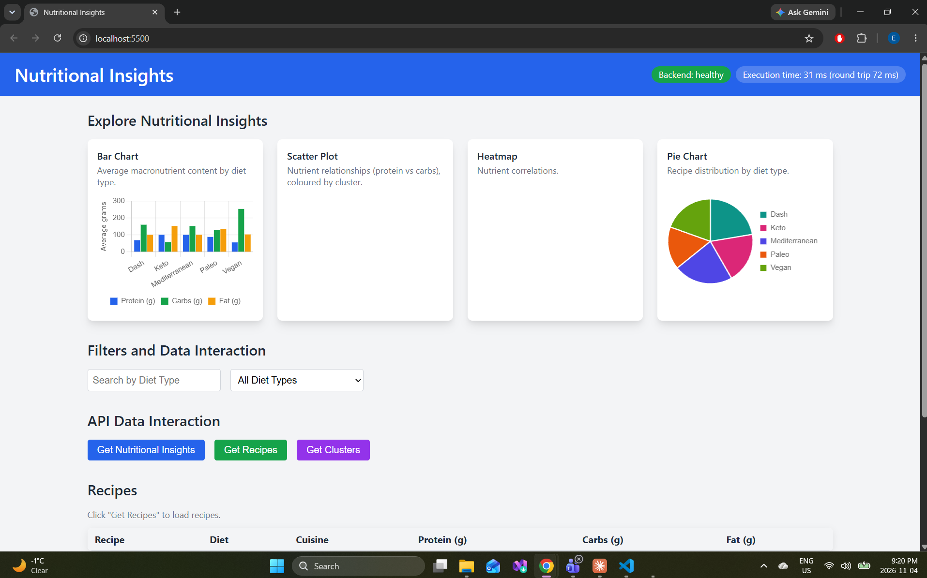
Figure 5 – Pie chart (sc 6). Recipe count per diet type, 7,806 recipes in total.
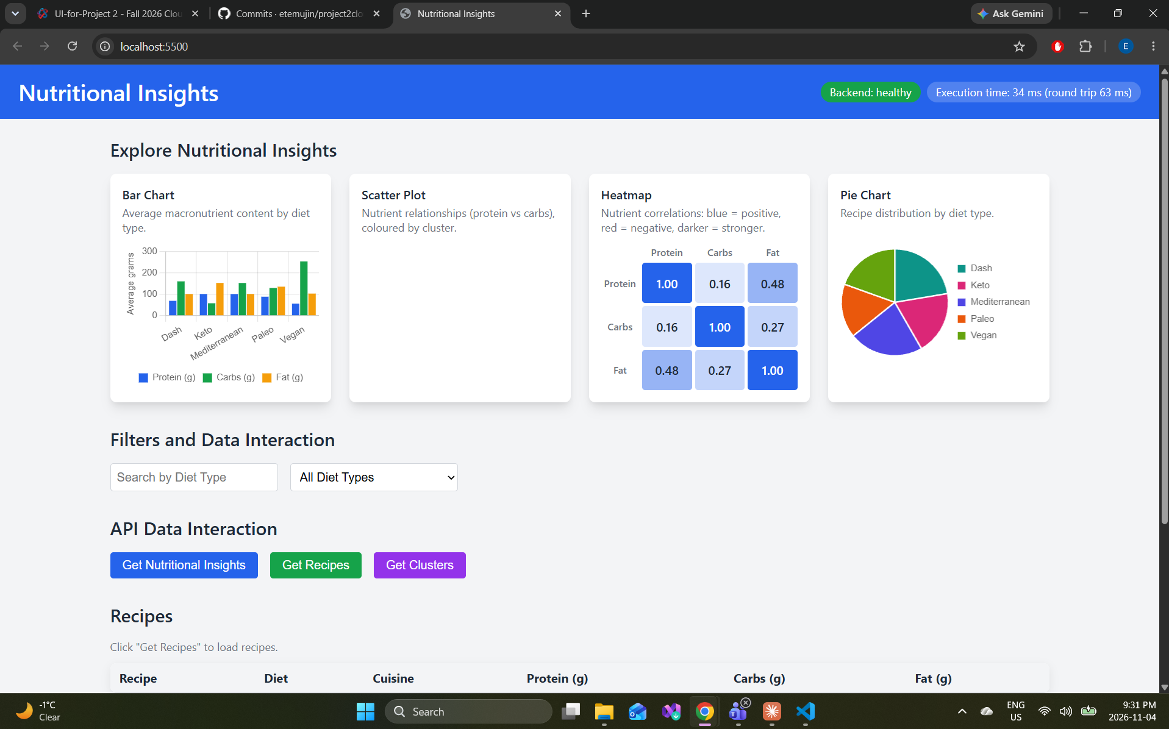
Figure 6 – Heatmap (sc 7). Correlations between protein, carbs and fat; protein and fat are the most related (0.48).
Integration

Figure 7 – Setup check (sc 1). A first test page on localhost:5500 calls /api/health on the Azure Function and shows its answer, "healthy".
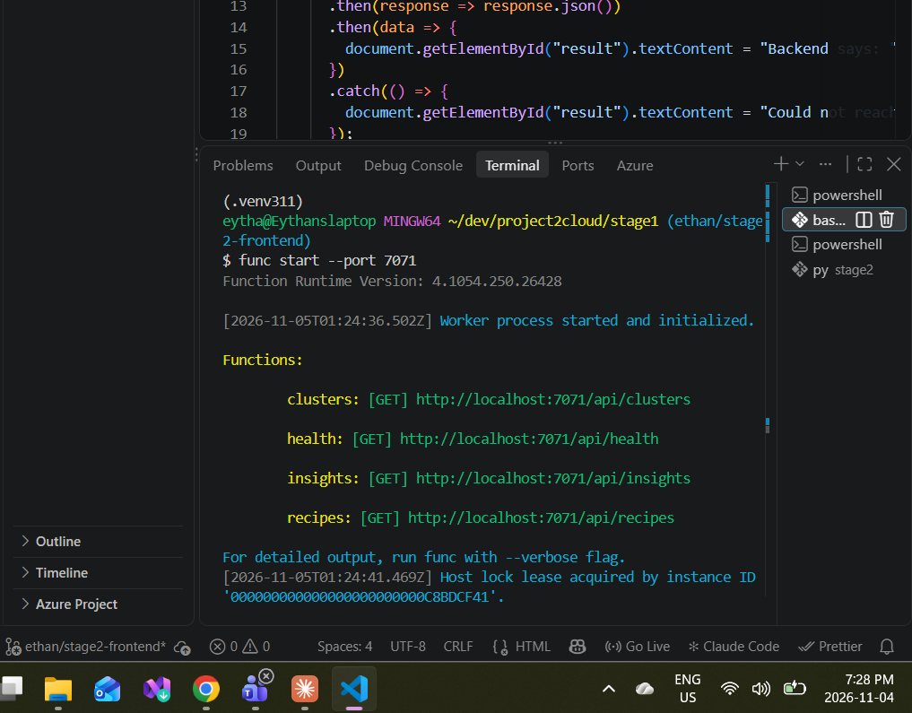
Figure 8 – Functions host running (sc 2). func start --port 7071 starts the Azure Functions host and registers the four HTTP routes: clusters, health, insights and recipes.
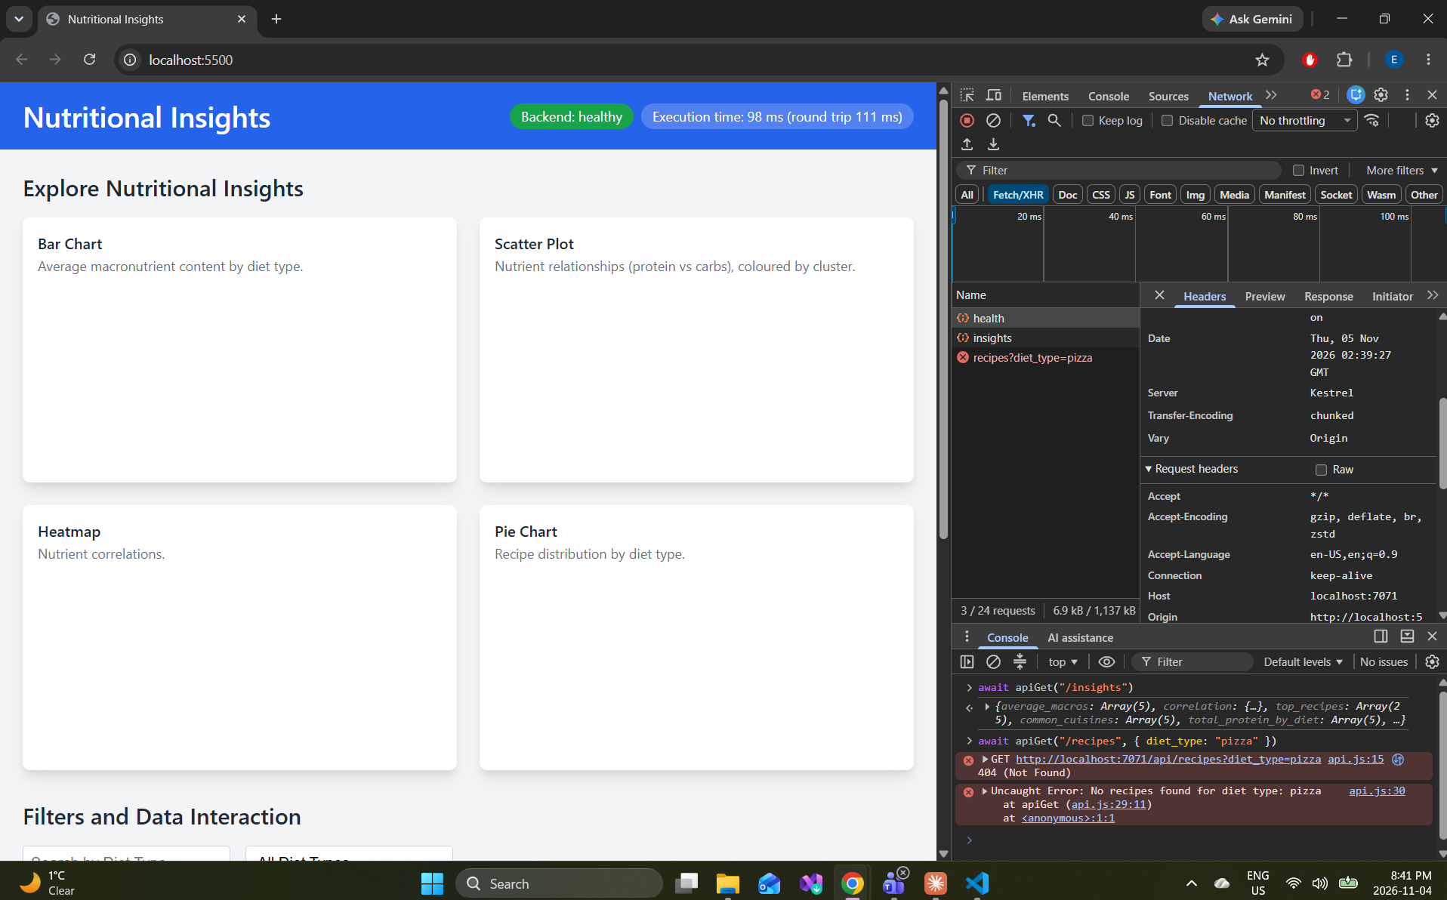
Figure 9 – Fetch helper and API errors (sc 4). The health badge turns green, and apiGet() is tested in the console: /insights returns data, and an unknown diet returns a 404 with the message "No recipes found for diet type: pizza".
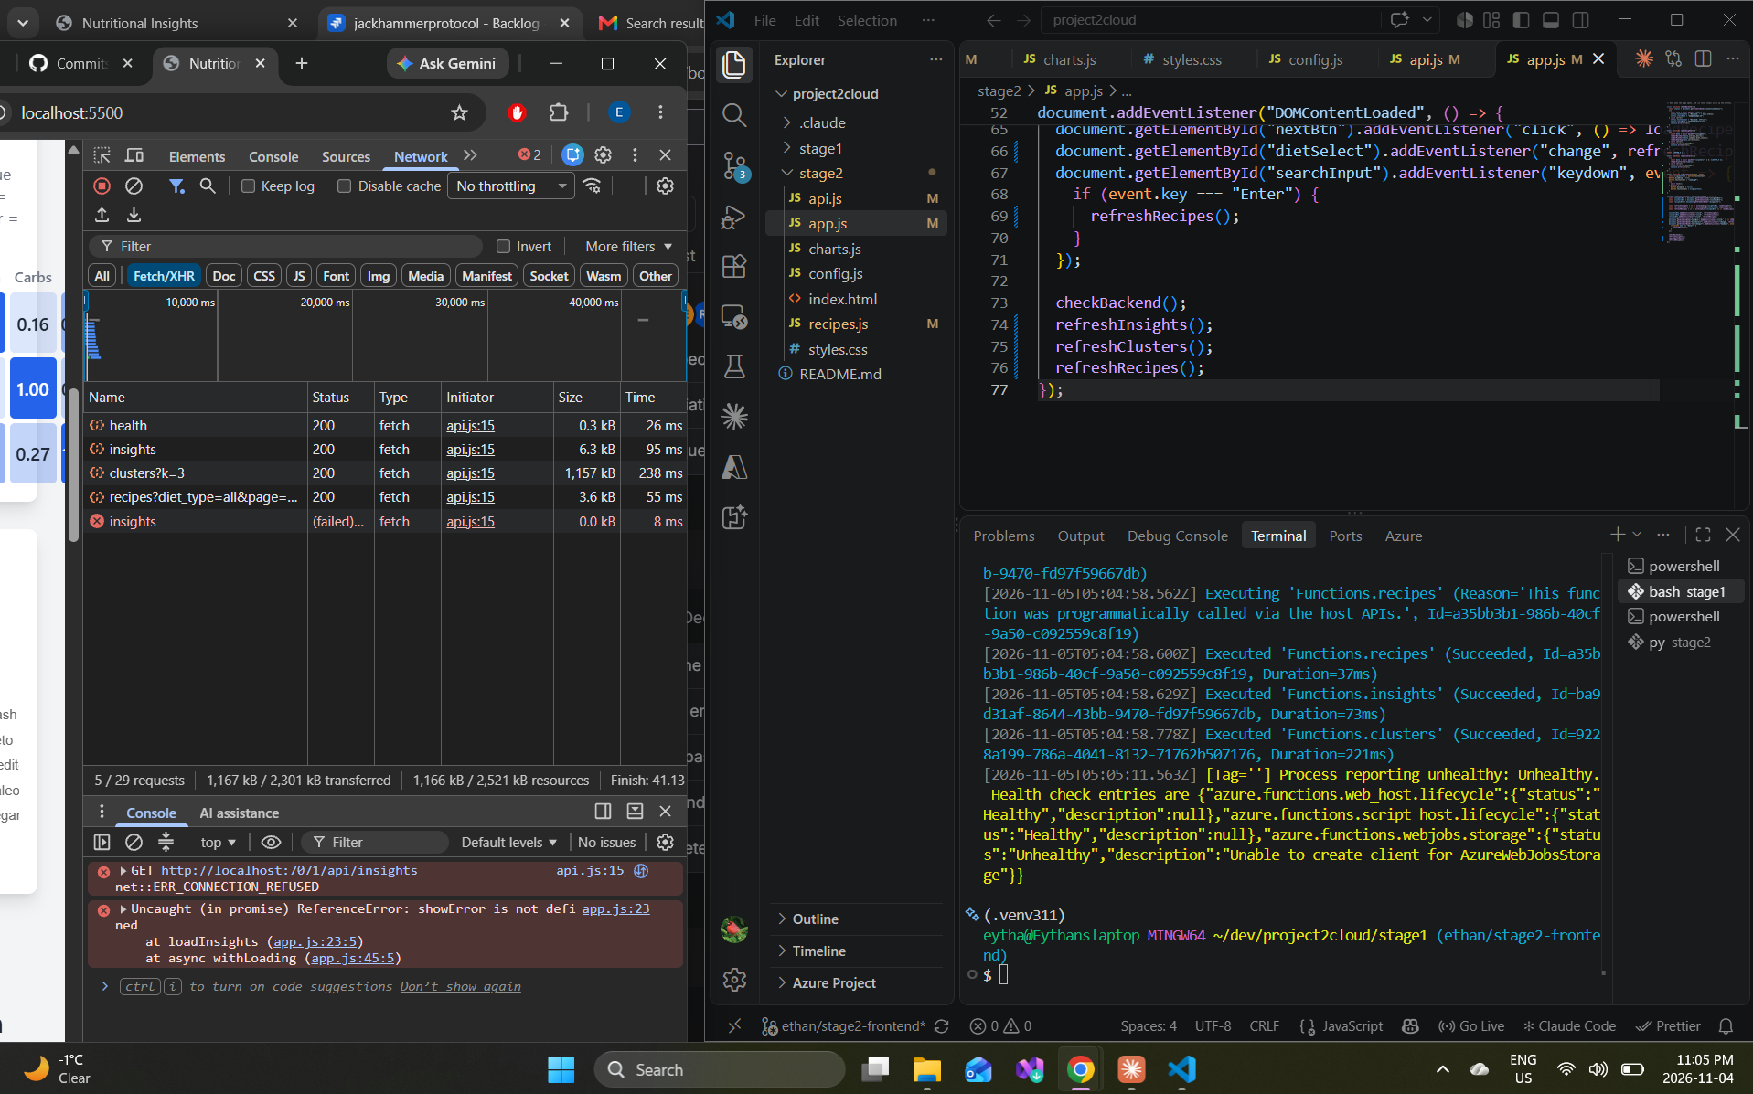
Figure 10 – Backend stopped (sc 10). With the Functions host stopped, the insights request fails with ERR_CONNECTION_REFUSED. This was taken before showError() was added; the final version shows a red error banner instead.
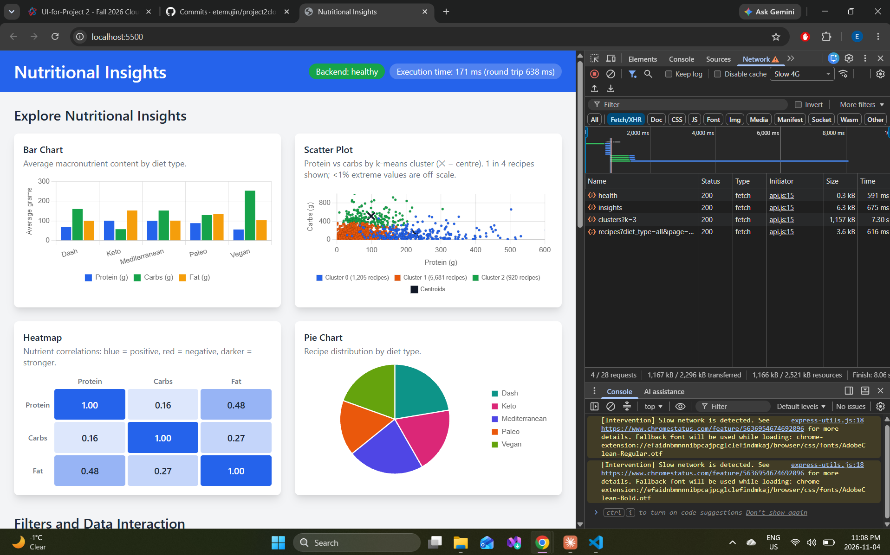
Figure 11 – Slow connection (sc 11). On a throttled Slow 4G connection every request still succeeds; the 1,157 kB clusters response takes 7.3 s.

